Q.1 Create the following star schema

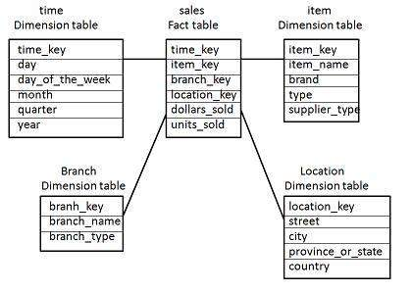

Q.2 Create the following snowflake schema

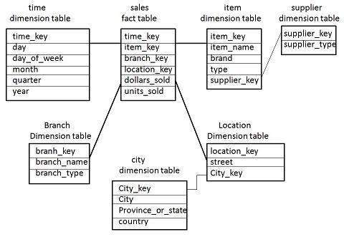

Q.3 Using Star schema generate cube for time wise, item wise, branch wise dollars_sold.

Q.4 Using Star schema generate cube for item wise, branch wise, location wise dollars_sold

Q.5 Using star schema generate cube for time wise, item wise, branch wise, location wise units_sold.